Work Pack 2

Hi everyone,

(I have written this ‘learning pack’ for parents to read to children. Not all activities will be suitable for all abilities)

It has been great to catch up with everyone over the phone recently. It sounds like you are all doing great! Remember I am here any time you need me.

My email address for this time is MissMCrean@gmail.com
Feel free to contact me with any questions or concerns. I would be delighted to see what you are working on and give some feedback. If you finish the work in this pack or would prefer to use this time to research a different project you are really interested in, let me know and I will arrange some resources for you.

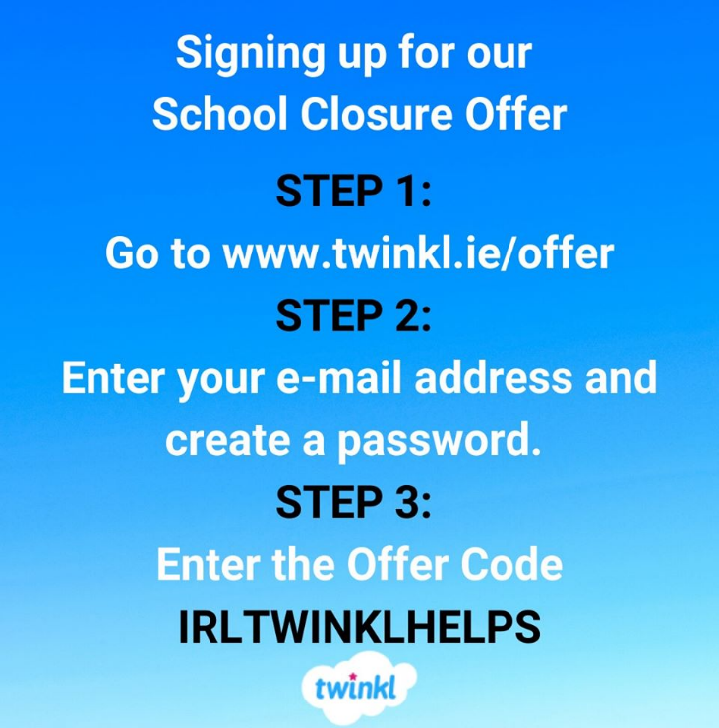
An excellent teaching website ‘Twinkl’ is offering free access to resources during school closures. Twinkl is used by teachers all over Ireland and this is a fantastic opportunity to access unlimited home learning. What about studying a new topic you have always been interested in or getting extra practice in with something you find tricky? Ask an adult to follow these steps and let them know what you would like to work on.

I have made an account for everyone in my class on ie.ixl.com which is used in some other schools. Everyone has their own individual username and password and I will be able to see what you are working on so I can see who is working hard! Just contact me at the email above and I will send on your username and password so you can get started.

There are resources and workbooks relating to a variety of subjects on the Learning Resources website which is due to be constantly updated during this time.

Maths;

One of the BEST maths resources I can share with you at this time is this link to daily maths questions. There is a set of questions for every school day of the year and for every year group! It is fantastic. Have a look at your ‘Master your maths’ Homework book. Whatever the number on the front (e.g. 1/2/3) start with that year group. Start working through day by day and send me the answers. If you have something in particular you are struggling with, let me know and we will find a way of working together.

Carol Vorderman is allowing free access to her maths website www.themathsfactor.com during school closures. Believe it or not she was an idol of mine when I was young! My mum used to buy me her books and I worked through them for fun. One of the ways we kept busy before the internet! Let me know if you do any work on her website and what you think of it.

Perhaps you want to revise some of your 3D shapes and nets by constructing them at home? This is a great idea using spaghetti and peas. Can you work out how to make the shape? Can you remember what a vertice is? Does the shape stack or roll? How many sides does it have?

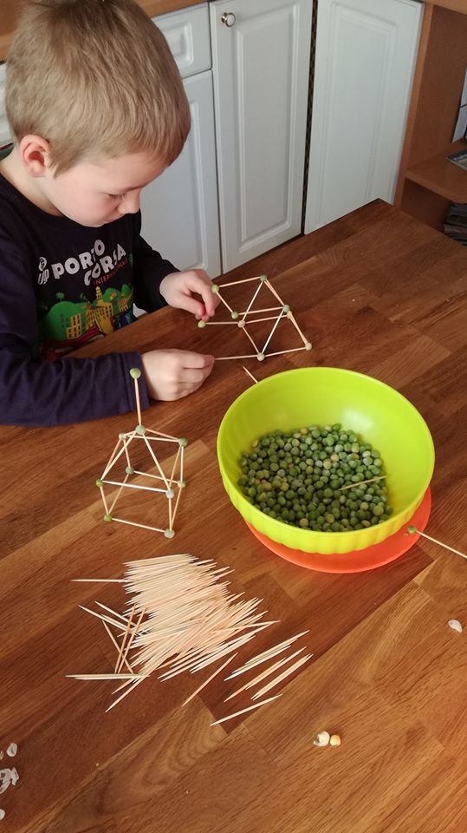

English

We had just started reading Harry Potter and I know a lot of you were excited about that. Luckily, the author J.K.Rowling has released the audiobook for free streaming on audible so you can still listen to the story like you would have in class! If you love Harry Potter, you might also like to check out the new Wizarding World Website to experience Harry Potter at home.

The author Julia Donaldson is doing a weekly broadcast which you can find here. (I have also linked a children’s book about Coronavirus illustrated by her illustrator Alex Scheffer in the SPHE section)

For early readers ‘Read Write Inc.’ has a set of online Phonics lessons revising sounds which you can find here.
Would you like someone to read you a story? My library at home has this great playlist of a lovely lady from the library reading stories. You might recognise the accent!

Remember the novel we read just before Christmas, Mr Stink? It was written by a man called David Walliams and every day during school closures he is reading audio stories for free. You can lie back and relax while listening to the story. At the minute he is reading stories about ‘The World’s Worst Children’! Let me know what you think of these naughty boys and girls.

Don’t fancy listening to David Walliams? Here is a more extensive link of authors that are doing read-a-longs for you at home.

I’m still waiting to hear some of your great stories via e-mail! We can work on a story together if you like. Email me the start of your story, I’ll add on the middle and you can write the ending!

Again I’d like to encourage you to keep a diary during this time. You are an important part of history and there are many people who will be interested in how children thought and felt at this time. This can be a good time to practice your handwriting but if you would rather you can make a video diary, audio recordings, drawings, photographs, type it up or do a mix of all these! Interview your parents, siblings or anyone else in your house to see how they are feeling. Maybe you will be showing this diary in schools in 50 years time and talking to other children about what it was like for you then! Share the diary with me if you wish or keep it private.

All children’s books are now free on Audible. Why not check out some of Roald Dahl’s other books or get cracking on the Harry Potter we had started? If you let me know which book you are working on I will tailor your work to fit the book.

For beginning readers the highly recommended ‘Teach your monster’ phonics app is now free (usually 4.99). If you use it I would love some feedback, we may adopt some of these apps when we get back to school if they are good!

‘Phonics Play’ are also giving free access to their website during school closures. The username and password needed to log in can be found on the home page of the website.

Why not have a go at a game of boggle each morning to get you started? Select a bunch of letters at random, or ask the other members of your household to select the letters. Put them in a grid like the one below and see how many words you can make using these letters. What is the biggest word you can make?

A | L | P | U
R | E | D | G
T | N | I | S
Y | C | F | O

Borrowbox from Dublin libraries are attempting to make it easier to sign up for their free audiobooks and e-books without having to visit the library. If you already have a library card you can get started straight away. If not visit the site to sign up

You can also sign up to a free 30 day trial of vooks.com which brings storybooks to life. There are plenty of options for books!

Check out Oxford Owl for Home. These are the guys who made the ‘Biff, Chip and Kipper books’. I read them when I was at school and you have probably come across them too at some point. The website has lots of free resources and activities for parents at home.

Science & Technology

Why not check out some of the Science and Nature videos on Maddie Moat’s youtube. Let me know what you think if you watch any of them!
A lot of famous scientists such as Brian Cox are providing science videos and lessons for while you are staying at home. You can find the upcoming schedule here.

SESE

We had a go earlier in the year at learning the songs of different birds. Listening to the birds can be very relaxing. Here is a link that includes some tips for learning each bird song, and clips to help you check if you were right! Here is another link to a similar article from the Irish Times

You might want to learn about the Easter Rising in Ireland. Here is a pack from EPIC with some activities relating to the Easter Rising.

If you have a garden you might want to have a look at this link about how to attract hedgehogs and badgers to your garden.

Want to see how big a certain animal would be in your house? If you type the animal followed by ‘facts’ into google you get the option to view many of them as life size via the camera on your phone or tablet.

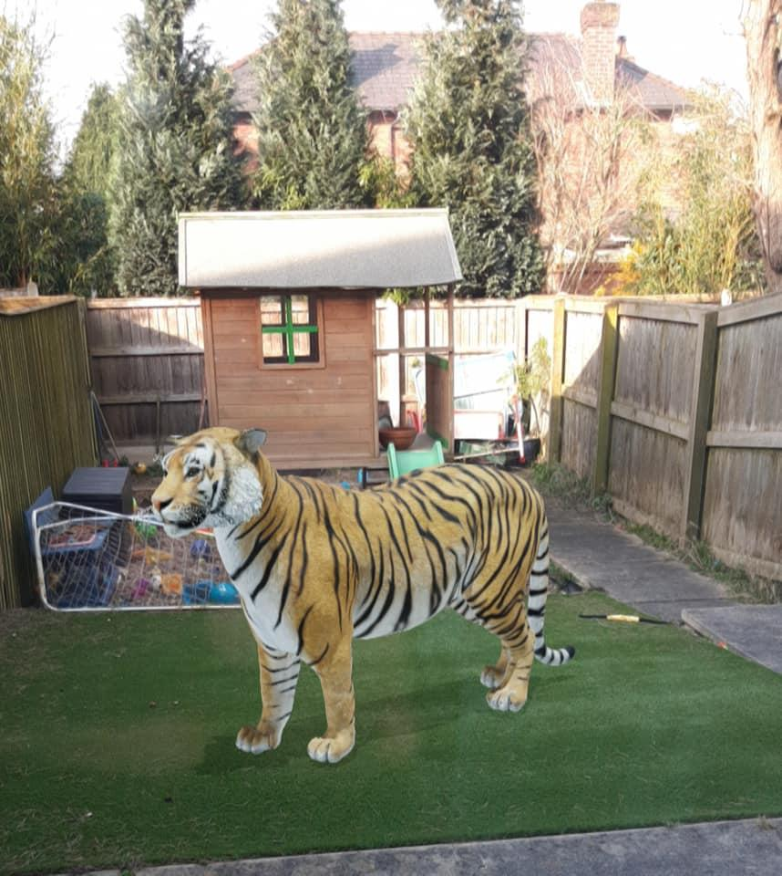

Art

Famous artist Mo Willems is uploading ‘Lunchtime Doodle’ videos every day that you can draw along with. Click here to see the episodes.

Irish artist Dan Conroy has also launched a Youtube channel that helps you learn how to draw your favourite animal.

If you have an adult at home to help you, you could try this craft of making a ‘God’s Eye’. This is something I had planned to do with you in school. Here is a link to a how-to video

Is there something you’ve always wanted to be able to draw? Why not look up some tips for how to draw it. Practice drawing it every day for 30 days. Compare your first picture to your last. Do you see an improvement?

Lego : I know lots of people in my class love constructing with lego. If you have lego at home, here is a 30 day construction challenge that will work on your creativity and problem solving skills. Send me pictures of what you have made!

SPHE
This is a very difficult time for everyone in Ireland and you might be feeling confused about what is happening. Perhaps you or your adult would like to read this book about coronavirus specifically for children. It is illustrated by Alex Scheffer - the same person who illustrated the Gruffalo! Can you remember what an illustrator is?

PE

I hope you are all still keeping fit at home! Hopefully most days you are getting the chance to get outside, but for bad weather or when family are too busy to go out; here are some PE ideas for inside.

Why not have a go at ‘Cosmic Kids Yoga’? We have practised yoga during some of our PE sessions. It is a great way to relax and unwind which is great during these stressful times!

Football Coach Robert Francis is offering ‘Stay at Home Football Coaching’. An adult will need to let you join this group via their Facebook account and should supervise. Other options on Facebooks include a 10 minute live dance shakeup at 1:30 PM every day on the DDMIX page

On Tuesdays and Fridays at 3:30 Splits & Flips gymnastics is streaming gymnastics sessions.

ICT
Scratch is also a great coding resource. Here is the link
Here is a booklet of easy scratch projects for you to work on. Let me know how you get on!

Music

Here is a song about colours I had really wanted to try with our class at some point. It will be very tricky to learn off so perhaps it is a good time now to start practicing while we are at home! If anyone can manage to sing along with this when we get back I will be SO impressed and they will definitely deserve a treat!
Why not treat your family to some of the songs we had been singing in school? I will link some of them below if you need a reminder.
I know everyone really enjoyed Bob Marley’s 3 Little Birds, The Rattling Bog, Molly Malone and I wanna be like you

Famous musician Mylene Klass has started ‘Mylene’s music Klass’ to keep you working on your music during school closures. There are currently 5 classes uploaded and they are around 10 minutes each. Enjoy!

Religion
You can access the Grow in Love program we use in school on their website www.growinlove.ie using the following login details
Username : trial@growinlove.ie
Password : growinlove

During this year we have been following the 2nd class program.
Take some time out each day to thank God for the blessings you are finding in each of these days. Share your worries with God.

Other
Why not have a go at cooking come recipes for your family by following the ‘Cooking with Kids’ playlist on Jamie Oliver’s Youtube channel or try a live cook-a-long with Theo Michaels

Here is a link to a set of indoor scavenger hunts for rainy days. Perhaps you could write your own scavenger hunt for someone else in your family and time how long it takes for them to complete it?

You might also want to have a look at the American version of Scholastic;s ‘Learn at Home’ website. Scholastic UK also have a bank of free resources targeted to each year here.

Here is a walk through of a relaxed non academic day with lots of outside time!

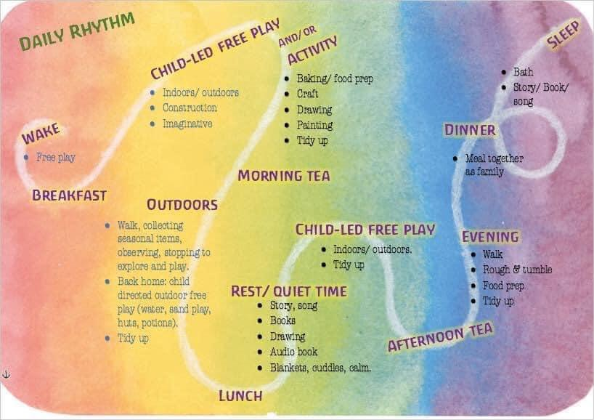

If you have plenty of time to access work online here are some more ideas for free websites.

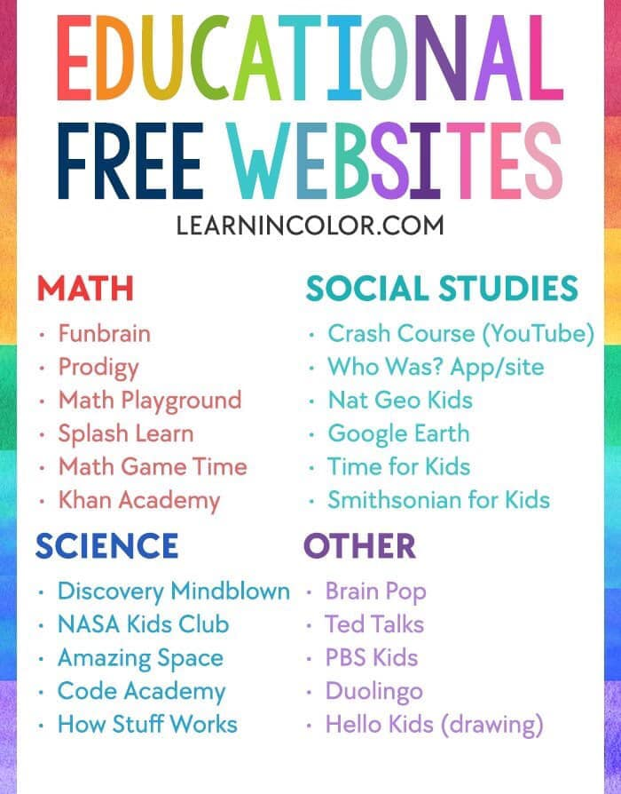

Here are some ideas for non-screen based activities you can do at home.
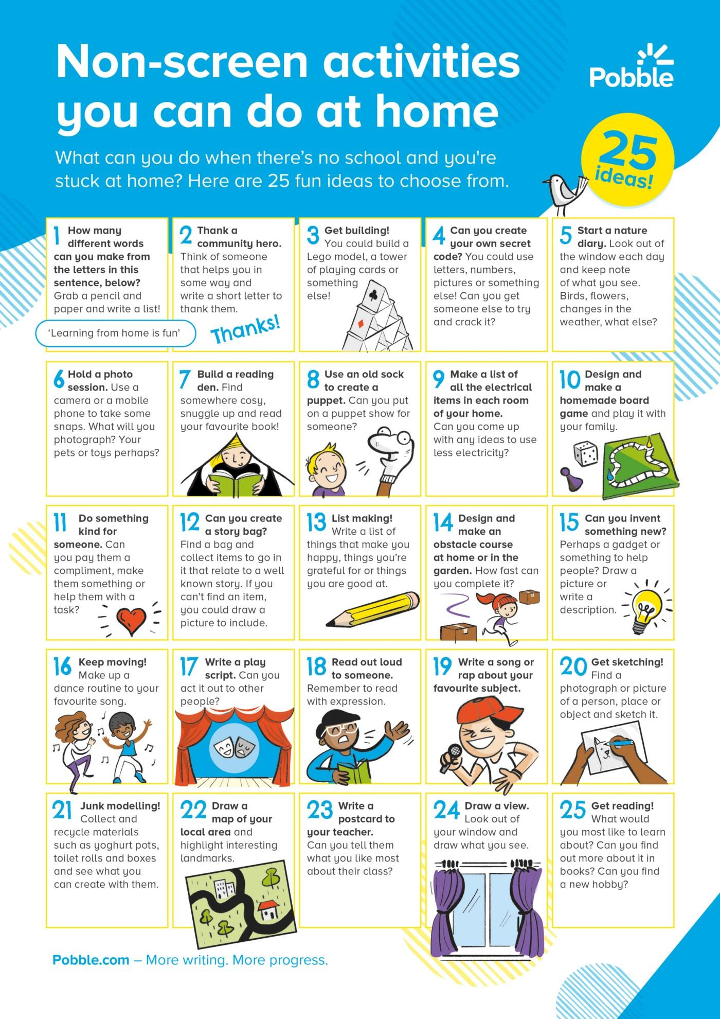

Lastly you may want to enter this Nature competition for the chance to win 50 euro! Looking forward to hearing from you all!
Miss Crean

