€1.29 €2.50 €5
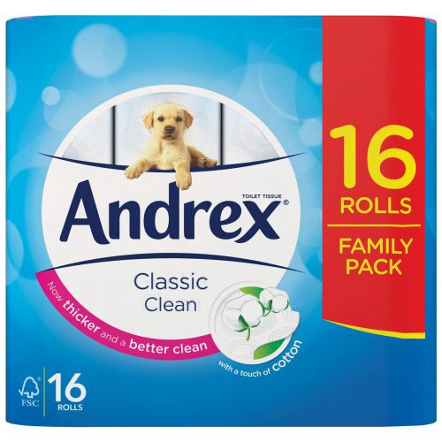
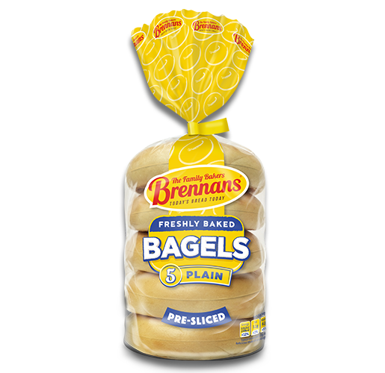
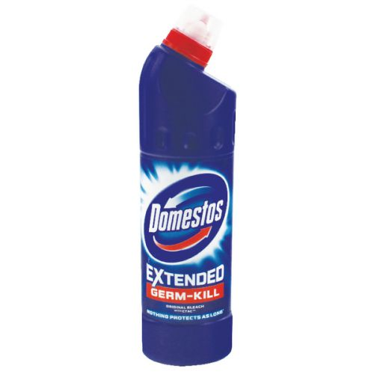

€1.10 €5 €1.20
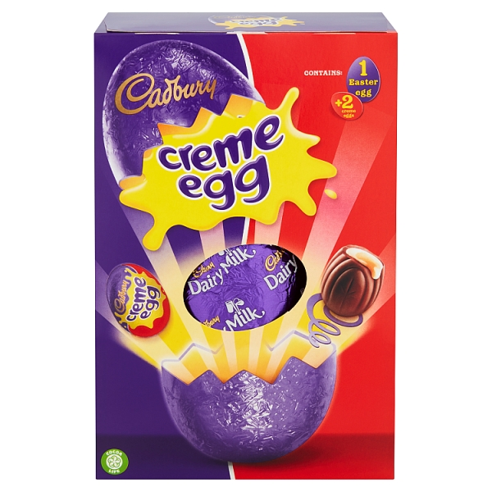
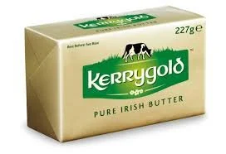
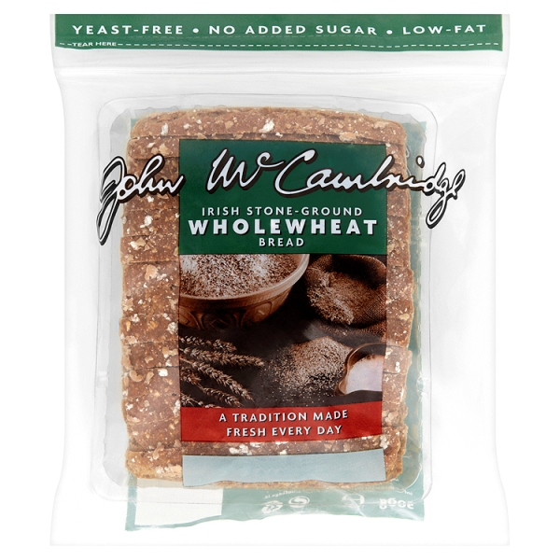

€2.50 €0.95 €2.50
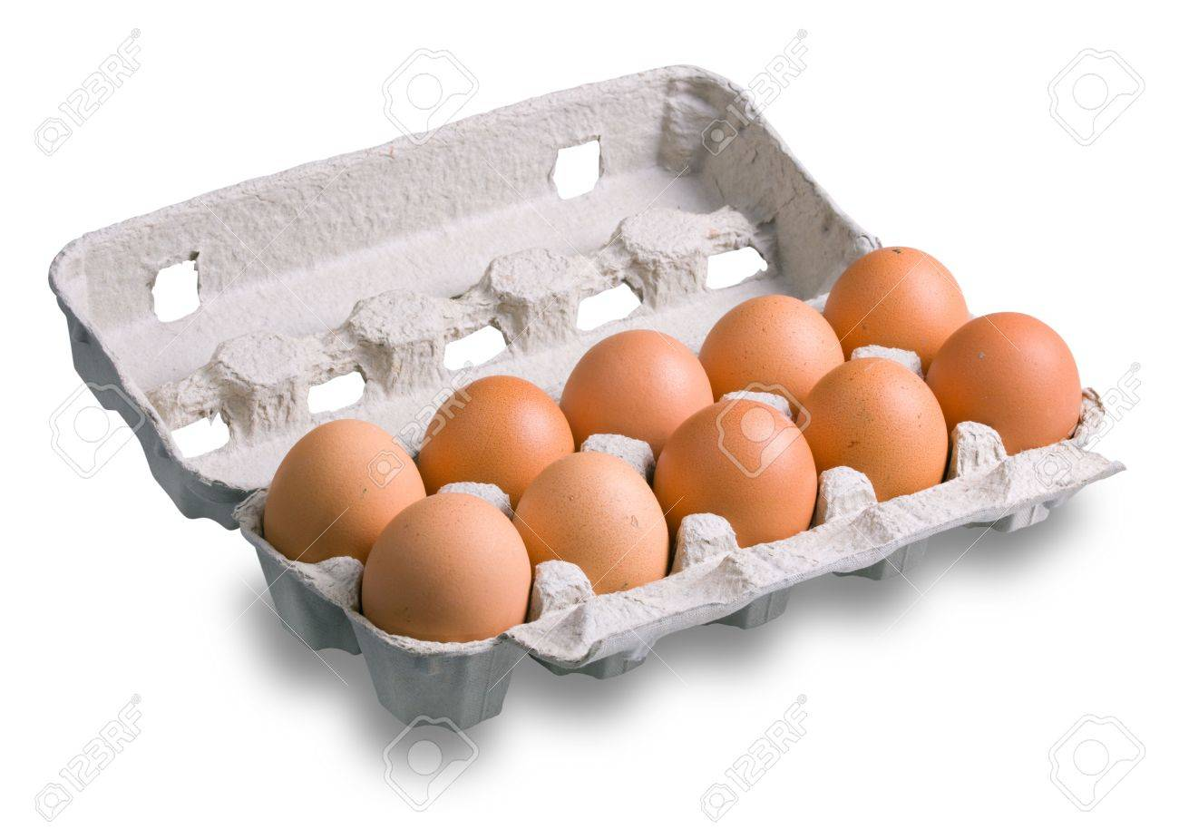
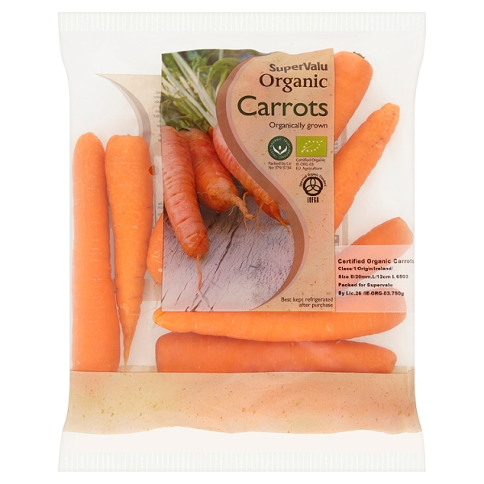
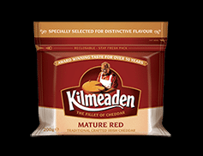
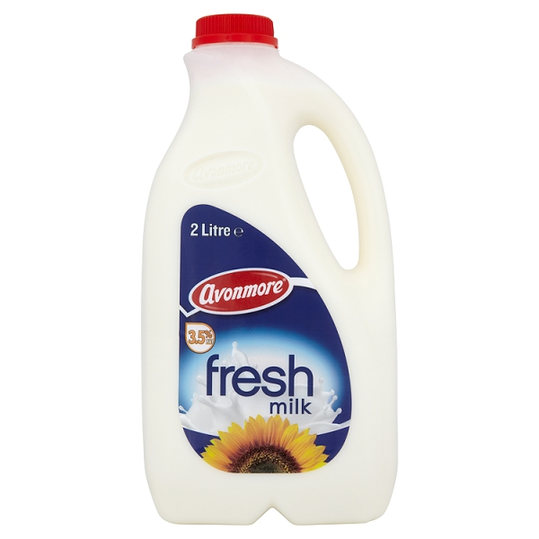
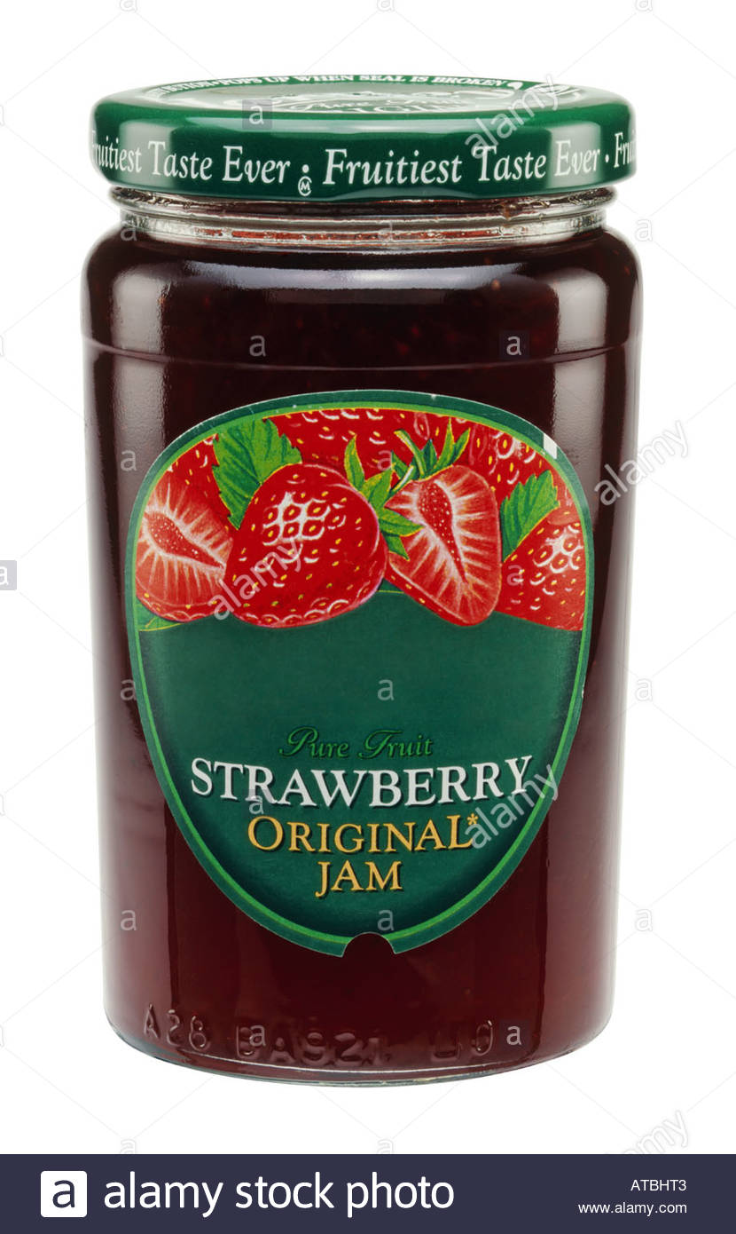
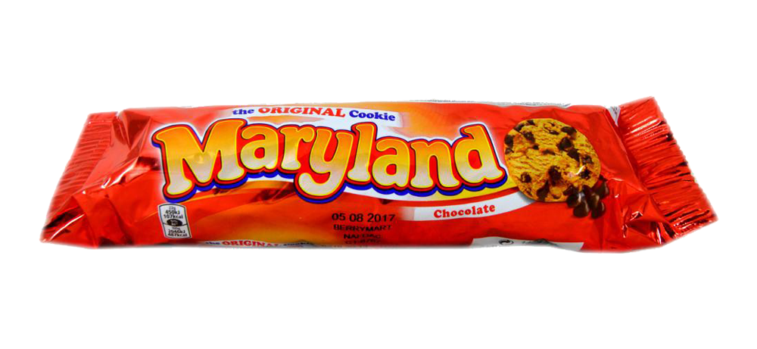

€2.50 €2 €2

- How many items are on the shopping list?
__________________________________________
- What is the most expensive item on the list?
__________________________________________
- How much do the butter and milk cost together?
___________________________________________
- How much do the jam and bagels cost together?
___________________________________________
- What is the cheapest item on the list?
___________________________________________
- How much do the carrots, biscuits and bleach cost?
____________________________________________
- How much does the Easter egg, jam and toilet paper cost?
____________________________________________
8. What three things would you buy from this list?
____________________________________________________________________________________________________________________________________
- How much would they cost all together?
____________________________________________

- How much is the total bill?
____________________________________________

