Hi everyone,

(I have written this ‘learning pack’ for parents to read to children. Not all activities will be suitable for all abilities)

My email address for this time is MissMCrean@gmail.com
Feel free to contact me with any questions or concerns. I would be delighted to see what you are working on and give some feedback. If you finish the work in this pack or would prefer to use this time to research a different project you are really interested in, let me know and I will arrange some resources for you.

I hope everyone is keeping well. Thursday’s confirmation was a great day and I am very proud of everyone in my class. I miss talking to you all in school and am looking forward to catching up when we return! This time at home can be a great opportunity to learn more about the things you are really interested in, connect with your family and develop or practice new skills you have always wanted to learn.

An excellent teaching website ‘Twinkl’ is offering free access to resources during school closures. Twinkl is used by teachers all over Ireland and this is a fantastic opportunity to access unlimited home learning. What about studying a new topic you have always been interested in or getting extra practice in with something you find tricky? Ask an adult to follow these steps and let them know what you would like to work on.

Here is an example timetable for a general learning program

7- 9AM | Wake Up | Eat Breakfast  Make your bed  Get dressed  Help your family with 1 chore e.g. clearing up after breakfast  Brush your teeth  Tidy your room
9 - 10 AM | Exercise | Yoga  Family Walk or Bike Ride  Joe Wicks Workouts  Dance  Kicking a ball in the garden
10 - 11 AM | Academic Time  Choose English or Maths | Choose from the activities below. Be sure to spend some time each day on maths and English
11 - 12 | Creative Time | Art, Creating Music, Gardening, Cooking, lego building drawing, crafts, act out a scene from a book you are reading
12 - 12:30 | Lunch
12:30 - 1 | Time to help (SPHE) | Ask an adult what you can do to help out in the house.  Have a conversation with someone in your family. Find out about them and how they are feeling
1 - 2 | Academic Time  Choose English or Maths | Choose from the activities below. Be sure to spend some time each day on maths and English
2 - 3 | Academic Time - Project Work (SESE) | Work on Rainforest related activities and research (below) and if possible begin to put everything you are working on into a project book we can look through when we come back
4 - 5 | Fresh Air & Nature Study | Do you have green spaces around you you can visit? Can you take someone in your family for a walk and play some of the games or teach them some of the things we learned in Phoenix Park?  Can you take your art supplies and draw some of the spring plants.  What plants and animals can you name. Can you research the ones you don’t know?  Look for shapes in the clouds  Take time to breathe and relax.
5 - 6 | Dinner | How can you help?
6 - 9 | Free Time

I have included a less academic ‘fun’ example timetable at the end of this document for when you and your family need a break. I have also included a compilation which shows useful apps and websites as well as exercise ideas.

Here is a list of ways you can make your time off interesting, beneficial and enjoyable. I had been really excited to start teaching you about the rainforest, it is a really interesting topic. I will provide a lot of links for you here and am excited to hear what you think.

Maths & English
Here is a link to a very comprehensive set of folders containing maths and english work for a variety of levels (you use some of these Maths and English books in school). Have a look for a book that you find tricky but not impossible. Don’t waste time on work that is too easy for you. Ask an adult to print out one maths and one English workbook for you. Try to print back to back and 2 or 4 sheets per page to save ink and paper. Maths & English Work Books - Easylearn
Maths;
Hit the button is a great practice and really improves your mental maths skills. Daily Ten is similar. Mental maths benefits you in all aspects of life, for example counting change in a shop or working out how many donuts you can afford! There is no point doing maths practice that is too easy for you. If you are getting 15-20 right within the minute, move on to something a little more difficult.

Here are some mental maths tests which are self marking and will show you where you went wrong. We tried one of these at the start of the year. If you complete both let me know and I will send on the next ones

Mental Maths Test 1
Mental Maths Test 2

We recently covered the time. Check the clocks in your house. Can you tell what time it is? Can you work out how long it was from one part of the day to the next? Time yourself to read for 15 minutes. How can you time that on the clock? Can you compare a digital and an analogue clock?

We have practised making recipes. Can you help your family by weighing ingredients when they cook? Can you help your family work out how much the bill for the shopping will be? What if they only wanted to make a half sized portion of the recipe?

I will link some other resources I had been planning to use this week. We are also working on collecting data and creating bar charts and graphs. Feel free to conduct your own surveys, let me know if you would like worksheets on this.
Halves and quarters of a number up to 100
Halves and quarters fraction bar matching cards
Jungle & Rainforest ‘ I spy and count to ten’
Jungle & Rainforest - I spy and add to ten

English
What a great opportunity to read! We are very lucky that World of books have released hundreds of free online books for children during this time of home-schooling. You can find the full list here; I’d be really interested to hear what you read and what you think of it. You could create a book review or summary of what you have read. You could also create some questions for someone else to answer once they read the book.

If you find reading tricky, start with this collection of early readers. There are lots of great Fairytales and myths from around the world here. A collection of books about animals

To show understanding of what you are reading, here are some comprehensions to work on related to our topic;
Leopards differentiated comprehension
Pythons differentiated comprehension

We were going to study story-writing in our last term. We can still do this over email! Make sure your story has (1) a beginning, a middle and an end (2) Interesting characters, a variety of settings and a problem to solve. Send me your first drafts by email and I’ll email back with ideas for how we can make the story even better!

In the last few weeks we had practised writing a daily diary. This is the perfect opportunity to keep up a diary so we can all catch up when we are back together. Talk about how you spent the day, what made that day different and most importantly how you are feeling. This is a very important time in our history. Maybe in the future other children will learn what it was like to be a child at this time by reading your diary!I would love you to send the diaries to me, but it can be private if that’s what you would like. I’ve also included an example mindfulness diary at the end of this document.

Science & Technology
This links to a great PDF with ideas for exploring Science and Technology for families at home.

SESE
Our topic for this term is the Rainforest. Your adult at home will need to use the Twinkl code above to access a lot of these resources. You are welcome to also do your own rainforest research on websites like natgeokids.com or through free access to World Book Online. I would be really delighted if you could keep all your rainforest work together in a project book so we can show each other what we have learned when we return. Here are a few links that might be useful.
‘Rainforest : I see, I think, I wonder photo Pack’
Amazonian Tribes Differentiated Comprehensions
60 second reads : The Rainforest
Tribes of the Rainforest differentiated comprehension (2)
Rainforest Calling e-book
Rainforest Information Powerpoint
Rainforests of the World Poster
Where are the tropical rainforests powerpoint
Rainforest Topic Key Word Mat
Layers of the Rainforest Powerpoint
Amazon Rainforest Mapping Activity
Rainforest Word Unscramble
Rainforest themed picture sequencing
Relying on the Rainforest Fact Cards
Rainforest animals differentiated blank fact files
Rainforest animals fact file pack
Animals of the Amazon Rainforest
Rainforest animals sorting worksheets
Rainforest animals Word search
Amazon rainforest animal adaptations
Rainforest animal fact file worksheets
Design your own rainforest animal
Extreme environments playing cards activity
Jungle and rainforests photo powerpoint

Extension : plant adaptations

Deforestation;
Extreme Environments : Deforestation in the Rainforest
Deforestation Facts and information
Deforestation debate pack

Rainforest deforestation persuasive writing information
Rainforest deforestation sorting activity

Higher Level;
Pedro guide to the rainforest
Pedro comprehension

Art
We have done a lot of Nature Study this year. Why not take a look at this catalogue of images from the Biodiversity library and see which ones you can recreate? Do you see any plants or animals you recognise? Better yet, get outside and draw them from life! Could you make a mixed media picture using natural materials? Send me your results!
Let me know if there is something you have always wanted to try or an art skill you want to improve on and I will send guidance and resources.

SPHE
Learn about yourself or an important woman in your family or community through completing this excellent HerStory project from RTE. I would be so excited to see your projects!

Why not keep a food diary and learn about how healthy your diet is? We were about to start learning about healthy eating. If you want to (anonymously) send me your food diaries we can compare and think of some healthy menus!

Here are some links to help you explore why smoking is unhealthy for your body. Your adult at home will need to use the twinkl code above to access.
Smoking Quiz Powerpoint
The Dangers of Smoking Close
Dangers of Smoking Crossword
Dangers of Smoking differentiated fact file
Smoking should be completely banned - debate pack
Dangers of Smoking ppt.
Why is smoking unhealthy ppt.
Anti - smoking photo powerpoint
Dangers of smoking labelling worksheet
Dangers of smoking word search
Things that harm us - smoking

Here are some resources about healthy eating
Keeping healthy ppt.
Healthy Eating ppt.
Food groups ppt.
Eatwell plate ppt.
Healthy eating sorting ppt.
Healthy Eating Activity pack
Healthy eating sorting activity
Plan a healthy meal

PE
Joe Wicks of the Body Coach is starting Daily PE lessons from home next week. You can exercise along with others kids all around the country and beyond. They will be live at 9AM each day. Joe Wicks also has plenty of other PE videos you can do from home if that’s not enough. You can find them here and here.
For the next few weeks I had planned to concentrate on GAA skills. You can find ideas for how to develop these skills on the GAA website here.

You can use these resources to find out why exercise is important for keeping a healthy body. What about trying this experiment. Measure your pulse before and after exercise. What do you notice? Write up a record of your experiment.

How our bodies change during exercise
Effects of exercise investigation
Our bodies during exercise
Joe Wicks - Why we need to exercise
KS1 - Joe Wicks - Why we need to exercise
Exercise is important science teaching
being active ppt.
Joe Wicks School Workouts on Youtube

ICT
We completed one course in the first term on code.org which helps you learn coding skills. Only one of you completed Course A but I have assigned everyone the next course, course B. If you complete it and want to do more just drop me an email! Code.org has also released a special set of links for how you can continue learning online during this time. Click here.

Just to remind you how to log in;
Go to this link : https://studio.code.org/join
Enter the special code for our class : QGFCSS
Click on your secret picture. Let me know if you don’t remember it!

Scratch is also a great coding resource. Here is the link
I will link a booklet of easy scratch projects for you to work on. Let me know how you get on!
You could also use this opportunity to practice your typing skills with games like ‘Dance Mat Typing’

General
Ask an adult at home to help you pick an art gallery or concert to enjoy. (Here is a summary of museums offering online tours) Send me a report on what you learned and what you enjoyed!

Save the picture below to be able to zoom in and read the links and ideas clearly.
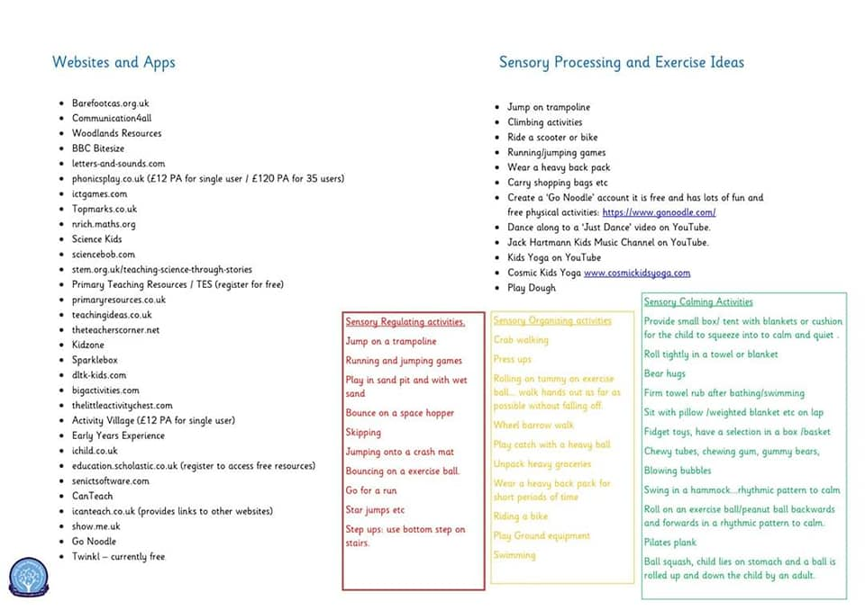

Here is an idea of a less academic timetable for those days when you might want a break from studying;

 | Monday | Tuesday | Wednesday | Thursday | Friday
9 - 9:30 | Audiobook (Youtube) | Pick & arrange flower | Bird Watch | Make & Write cards or postcards | Painting
9:30 - 10 | Build a Den | Party for toys | Scavenger Hunt | Boardgames | Write a story
10 - 10:30 | B | R | E | A | K
10:30 - 11 | Craft | Garden Ball Games | Water play (sink/bath) | Audiobook | Wash the car
11 - 11:30 | Board Games | Playdough (make your own!) | Gardening | Craft | Puppet Show
11:30 - 12 | Treasure Hunt | Classical music | Read | Bubbles outside  (recipe) | Garden Picnic
12 - 1 | L | U | N | C | H
1 - 1:30 | Make paper planes | Yoga (Youtube) | Collage | Kareoke (Youtube) | Read
1:30 - 2 | Read | Charades | Lego | Make a miniature garden | Junk Art
2 - 2:30 | Bubbles outside | Painting | Hide & Seek | Read | Board Games
2:30 - 3 | Dance Party | ISpy | Movie | Garden Treasure Hunt | Yoga

Finally here is an idea for a mindfulness diary you (or your adults) can keep while at home that helps you to take some time to appreciate each day.

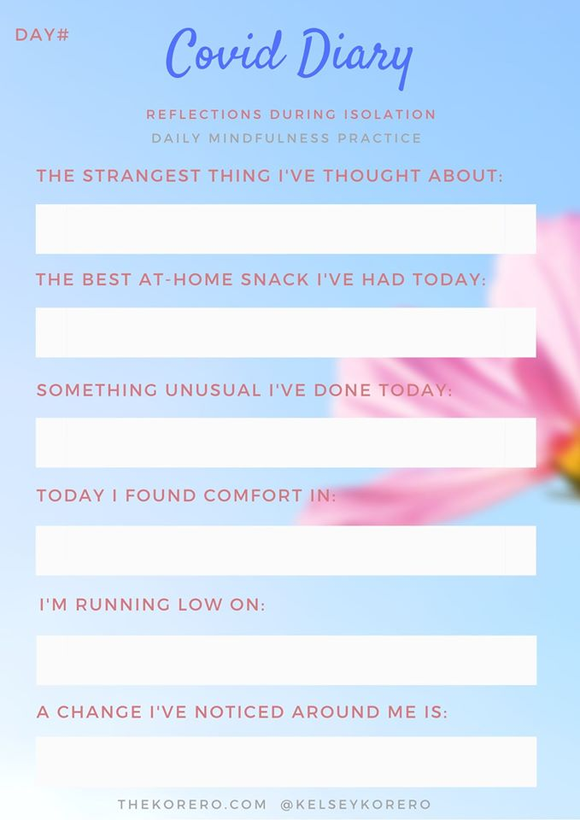

Looking forward to hearing from you all!
Miss Crean

