Interpret different forms of writing and text, including social signs and symbols
Read the comprehension piece below and answer the questions.

Adorable baby gorilla born at Dublin Zoo
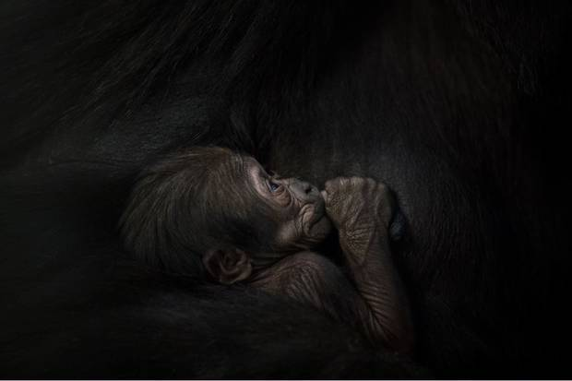
A western lowland gorilla has been born at Dublin Zoo. The baby gorilla was born to first-time parents mother Kafi and father Bangui. Kafi gave birth on 1st April, and the infant weighed around 2-2.5kg.
Dublin Zoo does not yet know the gender of the infant as the mother has been keeping the baby close to her chest.
The new born is the first offspring of Bangui since his arrival at Dublin Zoo last year.
Helen Clarke-Bennett, Team Leader or the African Plains at Dublin Zoo said: ‘Kafi is doing a fantastic job so far as a first-time mother. Bangui is proving to be an attentive father and at night has been sleeping close to Kafi and the baby. Kafi seems comfortable and at ease and we expect her to mix with the rest of the gorilla troop very soon.’

Questions:
1 What is the news headline?
___________________________________________________
___________________________________________________
2 What type of gorilla was born at Dublin Zoo?
___________________________________________________
___________________________________________________
3 When did Kafi give birth?
___________________________________________________
___________________________________________________
4 Why does Dublin Zoo not yet now the gender of the gorilla?
___________________________________________________
___________________________________________________
5 What is Bangui doing at night to protect Kafi and the baby?
___________________________________________________
___________________________________________________
6 True or false?
- The baby gorilla weighted 3kg? _____________________
- Kafi is doing a fantastic job as a first-time mother? _________________
- The baby gorilla is female? _______________________
- Bangui arrived at Dublin Zoo 5 years ago? ______________________

