LEMON DRIZZLE CAKE
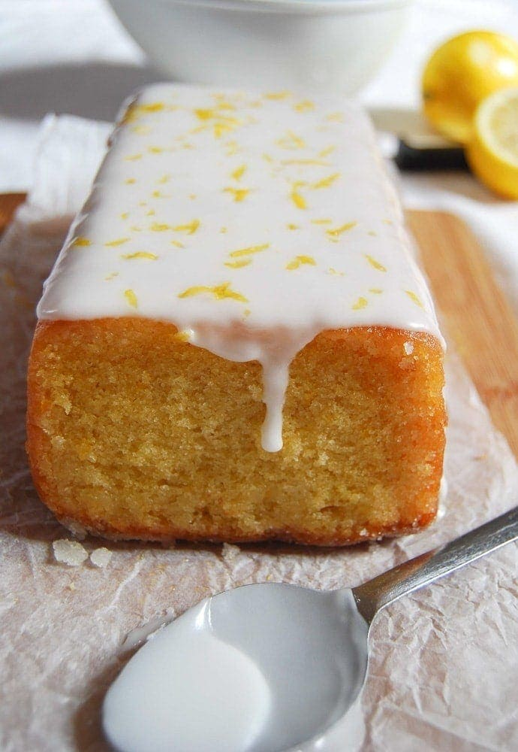
What you need:
- 175g Self Raising Flour
- 2 Eggs
- 175g Caster Sugar
- 150g Butter
- Rind of 1 Lemon
- 150ml Milk
- Pinch of Salt
For the Lemon Drizzle
- 2 tablespoons Granulated Sugar
- Juice of 1 Lemon

Method:
- Preheat oven to 180°C. Grease and base line a 900g/2lb loaf tin.
- Beat the butter and sugar together until well mixed.
- Add the eggs and lemon rind and beat again until well blended.
- Finally, add the flour, milk and salt and beat until mixture is smooth.
- Transfer to the prepared tin and bake for about 45 minutes until golden brown and firm to the touch. Remove from oven and place tin on a wire tray.
- Combine the lemon juice and sugar in a small saucepan and simmer over a low heat until the sugar has dissolved.
- Prick the warm cake with a fork, then gently drizzle syrup over until completely absorbed

Questions
- What is this recipe for?
_______________________________________
- How much flour do you need?
_______________________________________
- How much butter do you need?
_______________________________________
- How much milk do you need?
______________________________________
- List all of the ingredients that you need:
__________________________________________________________________________________________________________________________________________________________________________________________________________________________________________________________________________________________
- What temperature does the oven need to be set to?
_______________________________________________
- How long does the cake take to cook?
_______________________________________________
- What two ingredients do you mix together to make the lemon drizzle?
9. What do you use to prick the cake with for step number seven?
_________________________________________________

- What is your favourite cake?
_________________________________________________
Can you find a recipe online that tells you how to make it and what ingredients you need? Write out a recipe of your own on the next page.

__________________________________________________
INGREDIENTS:
________________________________________________________________________________________________________________________________________________________________________________________________________________________________________________________________________________________________________________________________________________________________
METHOD:
________________________________________________________________________________________________________________________________________________________________________________________________________________________________________________________________________________________________________________________________________________________________________________________________________________________________________________________________________________________________________________________________________________________________________________________________________________________________________

