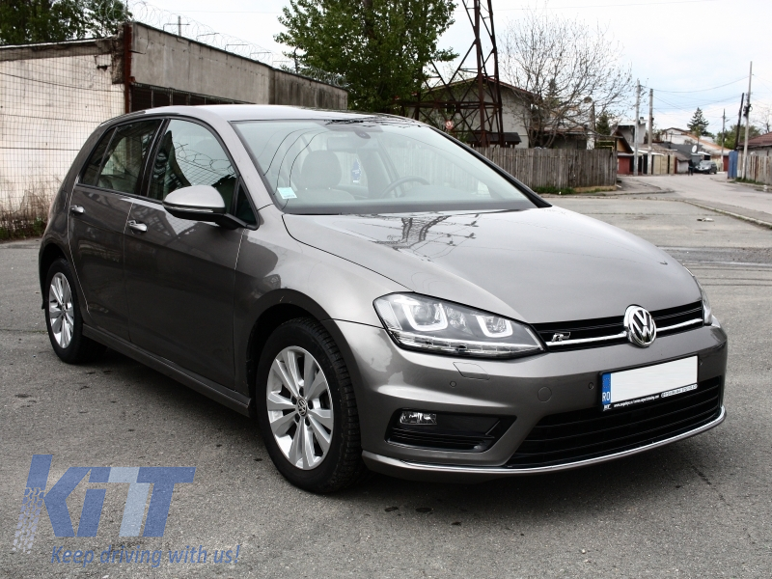
Car for Sale

Car for sale in Leixlip, Co. Kildare.
The cost of the car is €13,000.
It is grey and in superb condition.
There has only been one previous owner.
The car is seven years old and is a Diesel car.
If you are interested in buying the car or bringing it for a test drive please call Tommy.
My phone number is 087 988 7741

Questions:
- What is for sale?
_____________________________________________
- Is the car for sale in Dublin?
_____________________________________________
- How much does the swing cost?
______________________________________________
- What does the car look like?
______________________________________________
- How many people have owned the car before?
______________________________________________
- What sort of condition is the car in?
______________________________________________
- What is the name of the man who is selling the car?
______________________________________________
- What is his phone number?
_____________________________________________

