I hope you had a look and listen to the power point presentation on patterns around my house. Perhaps you could answer some of the questions I have put together. Before you do that I am going to give you a list of some of the mathematical vocabulary that you might like to use.

Pattern | Repeated Pattern | Symettrical
Similar | Different | Regular
irregular | horizontal | vertical
angles | sides | tesselation

. 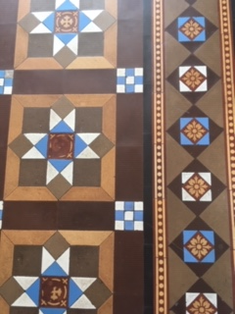

What shapes can you see?

What is the smallest shape in the picture?

How many different patterns can you see in this picture?

What is similar and what is different?

What size angles can you see?

What kinds of angles can you see?

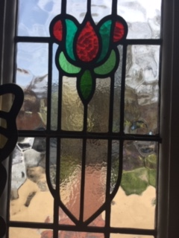

Describe the pattern in this picture

Investigate what shapes match together.

Could a circle shape fit in the pattern?

What does this picture remind you of?

Where might you find this kind of pattern?

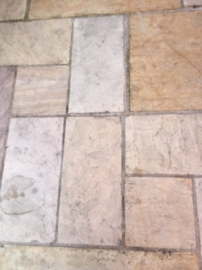
Footpath

Describe what you see.

What would the different surfaces feel like to walk on?

      What shapes can you see?

      Can you see any straight lines on any shapes?

      Can you use maths words to describe what you see?

In the second picture is the pattern the same?

Do these patterns tessellate?

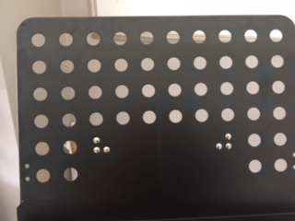

Can anyone guess what this is?

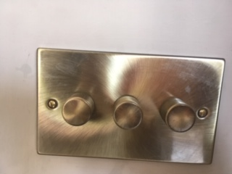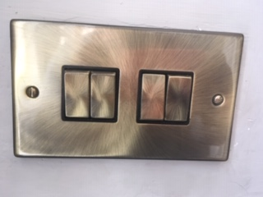

How are these pictures similar and how do they differ?

Name the shapes that you see in these patterns
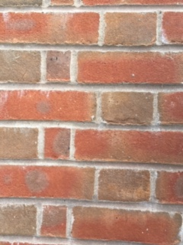

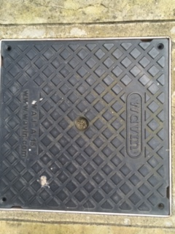
Name the shapes you see and then draw your own repeated pattern

