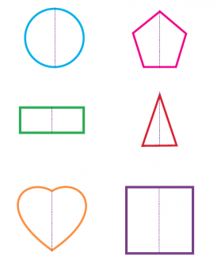
Cut out the different 2D shapes below. Fold the shapes in half so that both sides are the same. When you flatten out the shape, draw a line along the folder line you created. For examples, have a look at the image to the right.

This line that you have created is called an axis of symmetry. But it only works if both sides of the shape are the same. So, take your time when you are folding these shapes. When you have cut, folded and marked the axis of symmetry, glue the shape onto the assessment sheet.
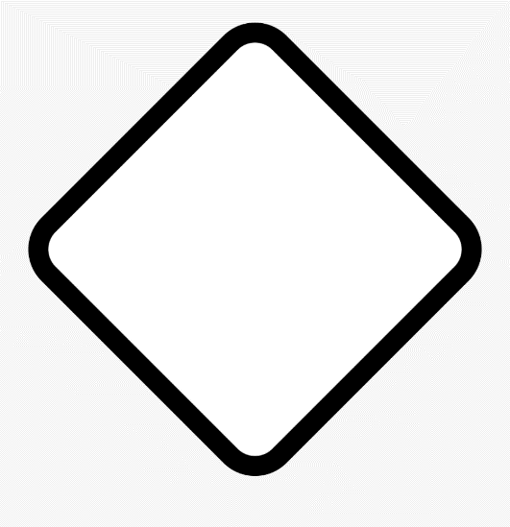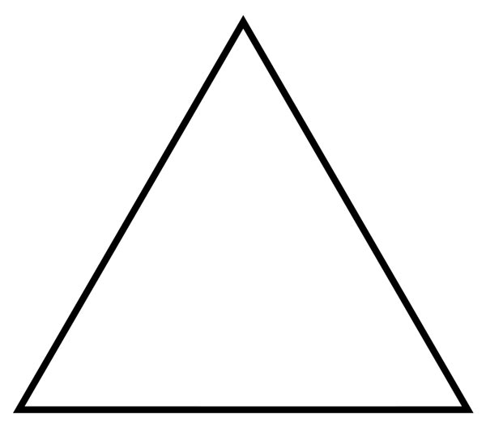

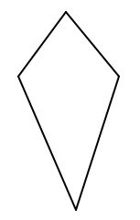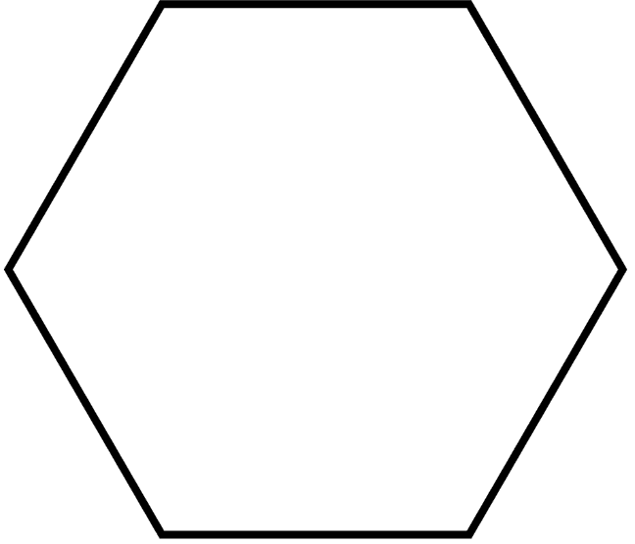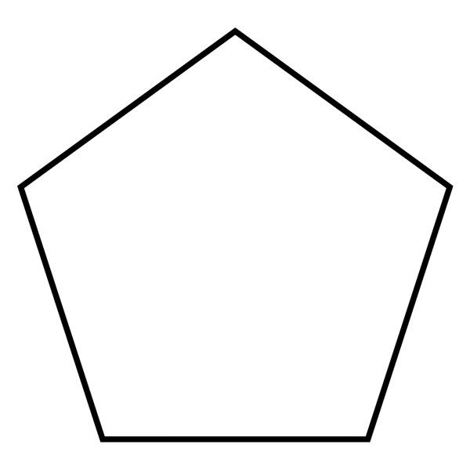
Find axes of symmetry of familiar 2D shapes and figures by folding, and mark them
Cut out the shapes on the previous page. Fold them evenly so that both sides of the shape are the same. Open out the shape and draw a line along the folded line you made. Then glue your shapes to this page. Take a photo of this finished page and email the photo to stpatricks.murphy@gmail.com.

