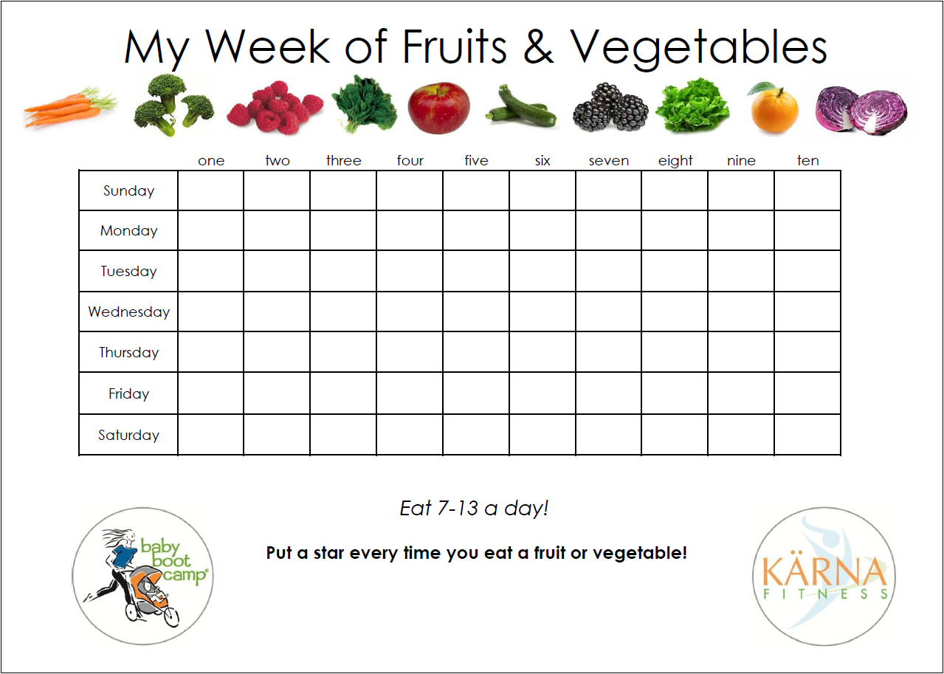

Day I ate least

___________________

Day I ate most

___________________

How many more I need to reach target of 5 - 7

___________________

**Total Each day**

**Target : 5-7 portions a day**