Find key information from different forms of writing
Meet the Hickory Horned Devil, a Fierce but Harmless Caterpillar
Hickory horned devil caterpillars look fierce and can be almost as big as a hot dog. Even though they look scary, they are actually harmless.
They have green bodies that turn turquoise as the caterpillar gets older. They have lots of prickled, orangey horns on their heads that make them look terrifying. They’re so big and fierce that even chickens – who usually love to eat caterpillars – stay away from them!

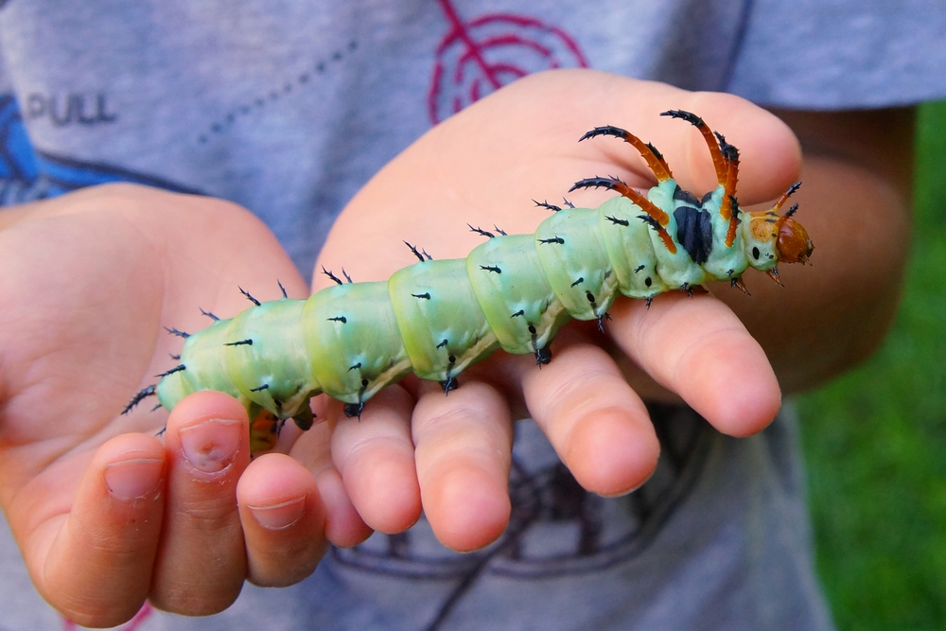

The hickory horned devil caterpillars get their name from their favourite meal – leaves from hickory trees. Examples of hickory trees include walnut trees, pecan trees, ash trees etc. But when they get the chance, the HHD caterpillar loves munching on insects too, especially mosquitos. They live in deciduous forests in the east of the United States. This is a good place for them to live because forests are full of delicious leaves and delicious insects!
Even though this caterpillar can grow to the size of a hotdog, the HHD caterpillar only lives for around 5 weeks as a caterpillar. At the end of its time as a caterpillar, the HHD caterpillar gorges on leaves before burrowing into the earth to live in a dark brown cocoon. The HHD caterpillars gorge on leaves because it will be their last meal ever! Once the caterpillar turns into a moth, they won’t be able to eat anymore. Moths don’t have mouths to absorb nutrients so it is very important for the HHD caterpillars to have a big last feast!
The HHD caterpillar turns into a beautiful moth with grey-green and orange wings. It is one of the biggest moths to live in the United States and it is one of the most beautiful too. Unfortunately, people don’t get to enjoy this beautiful moth for long because they only live for about one week before they die.

1 What does HHD stand for? _____________________________________________________
2 What colour is the HHD caterpillar? ______________________________________________
3 Look at this map of the United States and name 5 states that the caterpillar might live in.
- _____________________
- _____________________
- _____________________
- _____________________
- _____________________

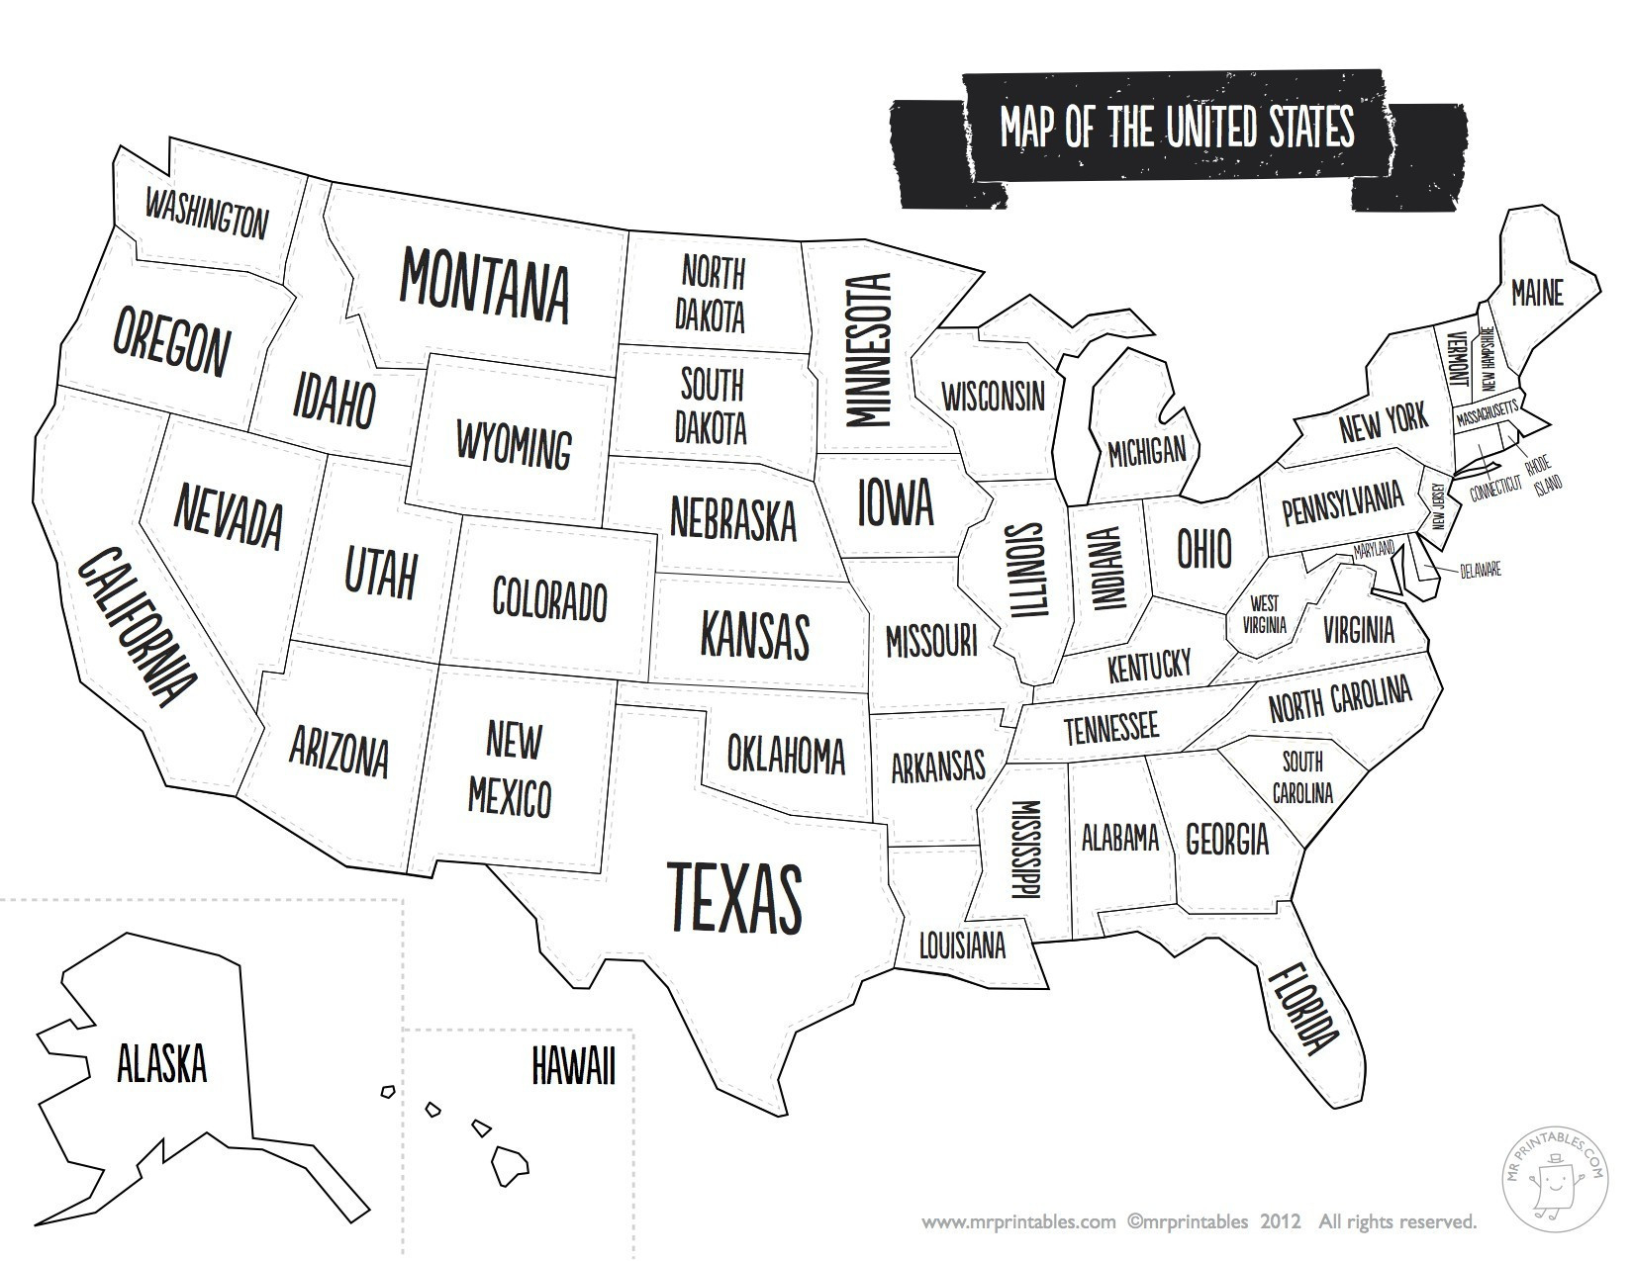

4 How long does the HHD moth live for? ____________________________________________________
5 The HHD caterpillar is known for being one of the most frightening looking caterpillars of all time. Can you create an image of a caterpillar that looks even more terrifying? Draw it in the box below and give it a name.
Name of caterpillar: ________________________

