Find key information from different forms of writing
This image shows a copy of an invoice. An invoice is like a bill. Read through this invoice and answer the questions. This invoice will also be used for Numeracy A4.
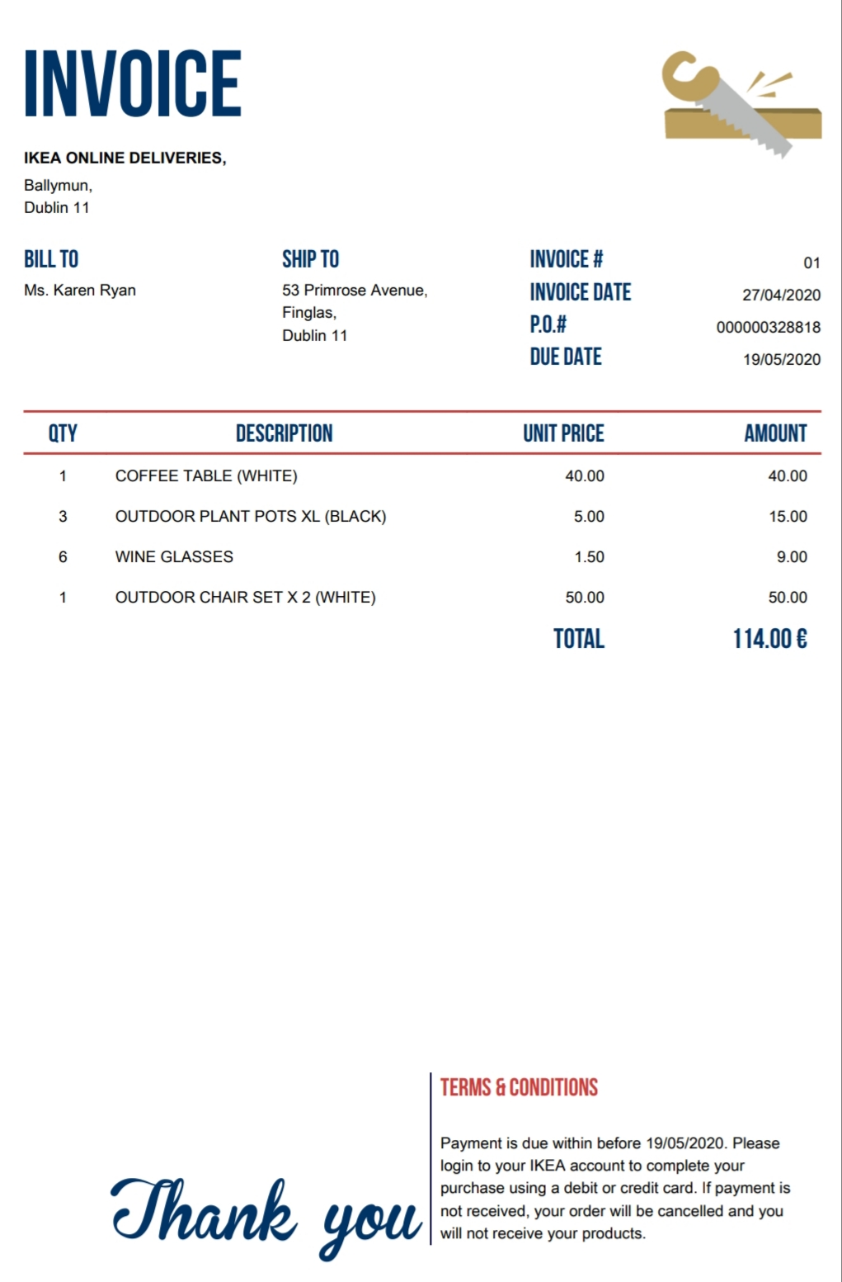

1 What is an invoice? ____________________________________________________________
2 Who must pay this invoice? ______________________________________________________
3 What did the person buy? _______________________________________________________
______________________________________________________________________________
______________________________________________________________________________
4 How many plant pots did she buy? ________________________________________________
5 How much was the coffee table? __________________________________________________
6 What was the total amount she spent on wine glasses? ________________________________
7 What colour chairs did she order for her garden? _____________________________________
8 What does ‘QTY’ stand for? ______________________________________________________
9 How much did she spend in total? _________________________________________________
10 When is payment due? _________________________________________________________

