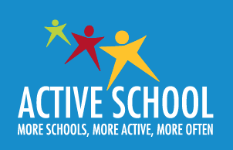

We are delighted to announce that our school is working towards its first

Active School Flag.

The aim of the Active School Flag is to promote physical activity throughout our school for all students and staff.

We are striving to achieve a physically educated and physically active whole school community.

Our Active School Flag committee is made up of 10 Senior students who are involved in promoting different physical activities and PE in our school.

They also contribute to our Active School Flag application.

Our overall aim is to get more active, more often.

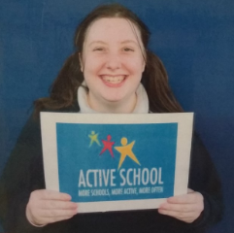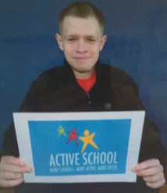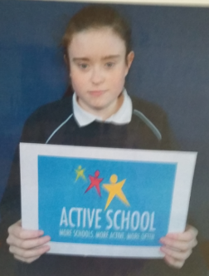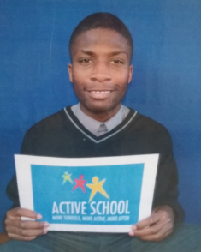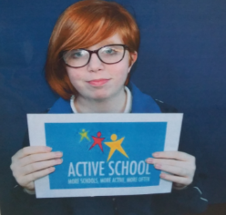

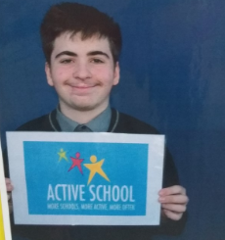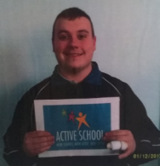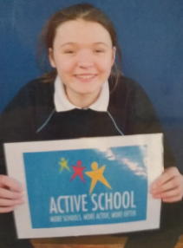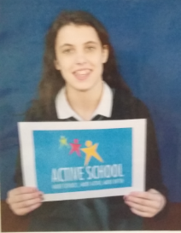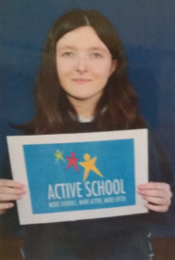

Physical Education at St. Michael’s School

There are 6 Physical Education strands within the Curriculum.

These strands are

Athletics, aquatics, outdoor and adventure, dance, gymnastics and games.

The Department of Education requires that every school carry out a minimum of 5 of the strands.

Our students use the swimming pool in Coolmine for a block of swimming lesson each year and as a result most students are able to participate in all 6 strands of the PE Curriculum.

All students are also encouraged to join clubs outside of school.

Active School Week

Our Active School Week will take place from

Monday 14th may – Friday 18th May 2018.

During this week we will have a wide range of physical activities for everyone to get involved.

Our students will take part in mountain walking, gymnastics, yoga, golf, GAA, basketball, football, circuit training, unihoc, rounders, yoga and our5km run in the Phoenix Park.

Physical Activities

As a member pf the Irish Special Schools Sports Council (ISSSC), our school takes part in a wide range of competitive and non-competitive events and physical activities including basketball, soccer, GAA, swimming, athletics, cross country and orienteering.

Each year we host a series of indoor soccer events where we invite other schools in our area to take part in A, B under 15’s, girls and primary levels matches.

